**Intelligent Interaction Room**

DATE：2011-10 Writer：All members of 5th Planet

Contents

1. Introduction to Group……………………………………2
2. Creation Mind……………………………………………….2
3. General Description of Creativity……………………2
4. Detail Description of Creativity

GUI modules………………………………………………….4

Network level………………………………………………..6

DNA & Core modules…………………………………….7

Management mode and Development mode…9

1. Examples………………………………………………………11

* Group：5th Planet

CDO：Yi Zhen CTO：Wangsi Zhong CMAO：Yiran Zhao

COO：Yiqing Li CMO：Peichen Duan

* Creation’s name：Intelligent Interaction Room

System property：Next generation intelligent interactive system and semi-open APIs based on the Internet of things.

Software Type：Next generation of comprehensive somatosensory interactive OS.

Hardware support（Not important）super servicer, area servicer, Holographic projection and somatosensory device , The Internet of things.

**Creation Mind：**

Social progress, changing times, cannot stop the pace of technology evolution. We ushered a new era. The computer which can only use bulbs to show the number, use the paper with hole to transfer the information until mature network-based multimedia advanced somatosensory containing device various type of PCs with tablet. We use the greatest invention in 20th century to help us finish all kinds of works and challenge more efficiently. At the same time, operation is more convenient than before. Even beyond imagination. But until now, we still have to adapt to a less familiar area, studying how to work with computer. From the perspective of the instinct of human who hadn’t learnt the operations of that how to use a PC, can’t use the PC even proficient in general. Fortunately, as technology advances and increased interaction, from the original MS-DOS era of complicated command line, to Windows graphical GUI with mouse operation, till iPad just touch the screen and efficient user experience. We simplify our interactive operation again and again. And increasingly rely on the ubiquitous Internet.

But, existing products still cannot satisfy the human "natural" demand. For instance, who want to select clothes and furniture in a 2D plane not in a 3D space? We prefer to true things, thus we can know if it appropriate, instead of reading boring text, and with image which never see the back. Try to imagine an environment with holographic projection, clothes can show comprehensive in your eyes, the furniture can be manipulated and selected by yourself. If you wave your hand softly, the device will recognize your action, and make the command to help you. This real-time online network-based system which based on the internet of things can also organized virtual reality meeting, teaching by your order. Conclude comprehensive game, sport in room .According to your personal preferences and habits, organized a image processing software intelligently best for you. These can run in a small space such as home, classroom, etc. Then, Next generation comprehensive somatosensory interactive OS will be born.

**General Description of Creativity：**

Intelligent Interaction Room (short for IIRoom**)**, naturally is a new generation interactive OS, It consist of three base levels:

Hardware level & Network level

GUI user level

Core level

Fig—1.1

**Hardware level and Network level**

Firstly, this system must be based on the ripe things Internet to control the exchange among a huge number of things effectively. Secondly, at least two server called super-server and area-server are needed for serve different function. The super-server is responsible for the overall interactive service and stores large amounts of highly encrypted user information. In addition, it also establish a secure virtual network access, support overall management of the transmission. However, area-server offer concrete services, such as holding meeting online and shopping online. Servers coordinate personal terminal to run the system. (Actually, hardware is not our pivot of the brief introduction. So, we may not talk much about it.)

**GUI level and Core level**

It is the core of our system that giving user perfect interface by holographic projection machines and somatosensory machine. In any room, user can issue commands to the system, mainly with their hands and voice. According to your directions, system can comprehend your demand and serve you though the “cloud” opening to the outside. After that, core level transfer command to the GUI level and GUI level show the user a hologram, so the user can instruct the system in the somatosensory way. We define Service flow sent by server “brain-wave”, because core level is like our brain, it can organize and combine brain-wave, and consummate its own DNA to provide stronger serve and feed back to severer at the same time.

For example, we design 3D painting software, user through the system call 3D graphics software. If user point that he need software that conclude modeling and action functions. Our system will extract DNA of them and combine into new software. And then feed back to GUI level, GUI level will do holographic projection. After that, User can make 3D graphics in the simulation environment.

**Features:**

With the high-speed Internet, growing amounts of online software and new shopping styles will make our life more effective than before. Users do not need full-servers, but just a GUI server. For most situations, users still needn’t install software by themselves’ download. Instead of that, they can call out the software from net simply. No phosphor, but holographic projection. With strong and safe “cloud” serve hierarchy, you will know huge amounts of news in the world. Furthermore, we offer extensive network of resources and realistic holographic interactive mode. Users are entitled to response their satisfaction or dissatisfaction to the system and our server will know more about your preferences and help you to select.

**Detail Description of Creativity**

**GUI modules:**

GUI

Vision

Audition

Reaction Operations

Core

1. **Enjoy Visual Effect！**

From when the first computer started its work on, there exist few GUIs that make its work outside a square display screen. Although the technology of display screens is becoming more and more mature and developed in material quality, color and distinguishability, the GUI is still stay in 2D, at most do a good job in simulating 3D images in 2D screens. Wondering when can we go into the colorful world in the screens and see fancy and porcelain stuffs while scanning widely around, and what’s more we don’t see sceneries outside the screens? The dream above will be a new era which the IIRoom brings to you!

The GUIs of IIRoom use advanced and powerful holographic projection technique to project a great many sorts of fine real time 3D scenes in a limited room. For instant, simulating shopping scenes, conferences scenes, outdoor sporting scenes and any scenes you want, even create a scene you image!

**Holographic Interactive Projection Technique:** It is sure that the developing holographic projection technique is widely known by people. But the most characteristic technique of IIRoom is not the holographic projection technique but the **Holographic Interactive Projection Technique.** It used omni-bearing 3D light projection to create a superlatively lifelike and vivid real-time dynamic-scene. Small room can be partly or omni-bearingly projected to simulate the real-time effect of scenes and object that are used to virtual projections, for examples, effects of light, shadows, movement of objects and element is to be easily projected. Want to watch a sport game live or see the goal in the position of goal keeper? Want to purchase a haversack in a Prada exclusive shop? Want to see the decoration blue print of your new apartment? Wish the colleagues far away to have a conference together? Want to inspect the result your fatty husband’s lose-weight plan? All is to be done!

**Small room High capacity:** What is needed to projected a vastly panoramic space is just small room. Maybe while using this, the users can just see partly, but it’s easy and convenient to change the angle of the scenes through many sorts of intelligent operations, so that every corner is to be projected and seen clearly. A voice command or action command given, IIRoom will change angle of virtual scenes and makes ‘never leave home to see the world’ come true.

**Cherish your eyes:** How can you keep your eyes from the harm of rays from a display screen, even the healthiest one, when you stay in front of it for a long time? What the Holographic Interactive Projection Technique needs is not the frequently-used fluorescent screens, but the Holographic Interactive Projectors and Holographic Interactive Cameras that produce much less radiation, automatically and effectively subdue strong light and moreover projected the desirable scenes intelligently.

1. **Enjoy Audio Effect!**

IIRoom provides the users with an audition experience which is to hear the real-time dimensional sounds in the space projected. Players of large-scale 3D games know that they will hear diverse real-time sounds or scene music when their game-roles change position. For instant, sounds of frogs and cicadas are heard in farm fields while sounds of guns and bombs are heard in war fields. Not only the dimensional sounds experience is brought but the experience of **Interactive** dimensional sounds.

**Open Choices of Users:** Users are able to choose music suitable for scenes from their own media library also from server-side. Users can choose sound effects that are exited also create sound effects by themselves. For example, users can record the sounds in current space and let system do the integration calculation then compile user-defined sound effects for users.

**Real-time Interaction Condition:** Generally speaking, it is a multi-dimensionalization communication of sounds. If a user is watching a game live in virtual projection, that his/her yell will be heard by other audiences who is projected around the user, so do the yells of them will be heard by you. Of course, all the yells can be heard by athletes. That is to say, IIRoom makes a multi-dimensional sounds world.

1. **Enjoy the Operations!**

Have you used any creative operational tool besides mouse, keyboard, hand shank and control stick? IIRoom simplifies its operations and realizes intelligent voice command and action operations like gestures, which make IIRoom itself convenient for users to use.

**Intelligent Voice Command:** ‘Give me a decent command and let me serve you.’ The Intelligent Voice Command System of IIRoom combines languages of many countries and region together; users can choose and load one at first use. Tell the system what you want, and the system will provide you with services you want through intelligent search. Of course, users are able to project a virtual secretary and let him/her ask you courteously: ‘Can I help you, master?’

**Assistant Operations for Disabled:** If the user could not speak fluently? If he is an aurally handicapped and he uses sign language to communicate? IIRoom is able to scan the commands written on the paper, provide loader sound, recognize sign language and even judge if you are dancing your arms and legs aimlessly.

**Action Operations:** It’s absolutely a great function to catch people eyes! Have you ever tried making objects in the distant fly near you by waving your hands? The Action Operations is like magic in *Harry Potter*, even sometimes you don’t need an incantation but several simple actions to change angle of virtual scenes, choose and operate functions of virtual objects, change their attribute and so on.

**Model of Memory:** IIRoom provides users with a memory functions for whatever ways of operations to record the operational habits and qualities of hobbies of users. This makes operations convenient for users and turns IIRoom as an assistant who knows your habits well! For example, ‘Come on, Alice’ to project your private virtual secretary and a right-hand crack to callout the menu.

**Network Module**

IIRoom network module is the core of the overall structure system, which contains the service module and the terminal of the module. First IIRoom general service flow is a series of transmission flow cluster, they have different pattern to different information transmission. But it meets the unity of the "brain wave" standard, so that we can avoid different signal interference, and integrate the same information conveniently. It also improves the information security. The whole module is supported by "IIRoom general cloud", here we introduce the service module and terminal module.

**The** **Server module** is necessary for the communication between each terminal and server. It is made up by these two parts: the super server and the regional server. The super server is established by the huge computer, even the super computer. The aim is the statement we talked about before: to store huge amounts of highly encrypted user information, to build a virtual network access of safety and to support of transmitting and overall management, etc. At the same time, it has exclusive "IIRoom-integrated DNA" core. The core can collect user terminal's information which can be open to others, the no-private DNA recombination information and the feedback, as well as compiling them, coupling them back and improving itself to make up a neural-like network of exclusive access and strengthen the communication. Super server is the biggest terminal management power. It has direct power of managing the regional server and the user terminals.

**The area server** provides specific services and online software. It can be provided by the third party. There is no limit to the server type. The regional service is also the biggest launch of "brain wave". Whatever it comes to shopping, meeting, instant messaging and on-line software, they can all get completed by the regional server. The regional server is apparent to the super server, but there isn't a direct power of management for the user side. And it must get the approvement by the super server each time a communication between the user side and it takes place. Regional server does not have a special "DNA core". The situation of the core is similar with the user sides. But it has the exclusive high bandwidth and the authority of the hyper-threading virtual "brain wave" path extension.

None of the servers and terminals can depart from **IIROOM general cloud.** This cloud is also the environment which IIROOM exists in. Because of this, the cloud consisting of the servers and the user sides have their collecting "DNA cloud". "DNA cloud shows the "cleverest" moment time after time. It can separate countless independent brains from the user.

**DNA & Core Modules:**

The core of IIRoom is divided into 5 types：I/O core, the main DNA core, integrated DNA core, communication core, Necessary Storage Core. These cores are all have their own DNA structure. We use linear relation to record the DNA and mesh relation to connect the capability, These five cores aren’t necessary, Let’s talk about them clearly：

**I/O Core**：The main meaning of this core is that the holographic projection somatosensory and voice identification of client. This core is very important. It’s the part which user concerned mostly and used mostly. This core is in charge of coordinating all physical components and controls them to run well. The core receives the input information and analyzes the information of abstraction. The analysis answer will be put to other components to do some interaction and feedback the information to user. It controls classical input components：mechanical keyboard, camera, microphone and holographic input. I/O core fix the command by the main DNA core. The main DNA can analyze the text and holographic projection. I/O Core can choose the output mode automatically.

**The main DNA Core**：This is the most important core in IIRoom. It can analyze the data, recombine DNA, intelligent to evolute by itself. In fact, it is also the compute core of client and server. The why we call this core the main DNA core is its capability of recombine DNA. Analyze the data and compute is its main ability. It is the head of all cores. The main DNA core can control other cores straightly and only can control other cores. Other cores must take the data, operation system, commands to the main DNA core. Then the main DNA core controls other cores to finish various works as a central leader. It can：collect the data（I/O, communication, DNA information）,finish the command, control other cores. It is the only core can recombine DNA by itself. The main DNA core can organize the DNA and don’t change the architecture.

**Integrated DNA core:** It is the core that just belongs to the super server. It is in charge of collecting the DNA stream from the users' "brain wave" and analyzing, as well as integrating a new general self-adapting DNA to make it convenient to mend it better, to make users and the regional server a better experience of users and evalution of itself. Furthermore, there is a concurrent expanding ability of several super server by communication cloud sharing. This kind of jointly self-mending is called "propagating wave field". Only the super server is able to visit "propagating wave field", just like an exclusive attaching network.

**Communication core:** This is the module that having its own security core and handling encryption and decryption of brain-wave. As if the petrol needed for a car, IIROOM is nothing without the communication core. Besides, communication core sustains receiving and responding the hyper-threading brain-wave. Not only that but also advanced function of building network, can request for the super-server to build dedicated information access. (No special restrictions). Another way is building local area network among nets to be authorized. (Special restrictions)

**Necessary storage core:** The client needn’t storage core except backup data. Otherwise, the storage core is just built in super-server and area-server, which memory amounts of information and software. To meet the demand of more and more storing, storage coreapplies bionics to imitate the human brain’s storing. With the support of the main DNA core, it use self-increased, self-less and dynamics storage mode as neurons. Different from traditional storage mode, IIROOM’s storage mode has optimized data model.

**Under normal circumstances:**

Super-server: I/O core, the main DNA core, integrated DNA core, communication core, necessary storage core.

Area-server: I/O core, the main DNA core, communication core, necessary storage core.

Client: I/O core, the main DNA core, communication core.

I/O core

***The main DNA core***

Necessary storage核

Communication core

Integrated DNA core

IIRoom architecture

**Management mode and Development mode:**

1. **Management mode of IIRoom:**

* According to the framework of IIRoom, there is a both-way feedback channels between GUI and Network. And the core of system connects the network directly. That is to say, the data of users including habits, settings and privates, will synchronize with super server-side automatically under the safeguard. It permits users to load the accustomed settings at any time and place. And there exists a feedback link between the synchrony of data and the security department of government, equal to gain safeguard and independence.
* **User Registration:** Users have to register at the first used. IIRoom is a highly virtual system, so the data of users has to be fully complete and be proved secure. The security proofs decide the user type which restricts users’ items of function experience. Users should submit identity proof and health proof of both physical and mental(proved by the security department)first, then submit the physical index by scanning by holographic cameras, etc. Finally, the data of users will be uploaded to super server-side and build permanent private files that are renewable. Only user or the security department of government gets the permission to read and load the data files.
* **User Login:** Every time when the user logins, the holographic interactive projector will automatically scan the user to get the physical index meanwhile submit it to the super server-side through network. Then the server-side will compare it with the standard data of the user and load the data to core to make the login if the information is matching. When the physical index of user change a lot, the user has to have further identification like checking the fingerprints, pupil image of eyes, voice or even the DNA.
* **Updating of User Data:** Every time when the user uses the system, the physical index of user will be scanned and upload to the super server-side for data updating. The system will remind users of full-scale information updating periodically. The system can connect the super server-side and get some users’ information saved in network which is certified. So virtual won’t be inveracious but under safeguard and reality.
* **Safety protection management:** The users’ information saved in the super server-side is permanent files that can only load by owners or the security department of government. It will record detail contents at every updating and nobody would get the prerogative to add, delete or alter the files out of date.

1. **Development mode** **of IIRoom:**

The Development mode of IIRoom gives the users a privilege to create a most personalized and suitable virtual world by own. Although the third parties have made and uploaded a good many virtual models in the area servers for customers free or with cost, the most attractive function is still the independent development of user. The works of users are able to upload to the area servers also be saved in the secret data of users for loading at any time.

The objects in the real world that can be scanned by holographic cameras can be projected in the virtual world. For instant, shop owns are able to project the real goods to sell in virtual shops created by own, or self-define the shop style even meet no problems while decorate their virtual shops. Users are going to enjoy wonderful creations from deep mind in the virtual worlds as long as they have great imaginations and creativities.

The Development system of IIRoom provides ample safeguard, for the system will tell from and embody what are real objects, what are virtual objects projected base on real objects and what are created by users at root. It ensures that users will not go into conditions that cannot be distinguished real or not and then be cheated or harmed.

**Example:**

What can IIROOM bring about our life? We might as well use three examples to illustrate it.

**First: Help you select appropriate furniture.**

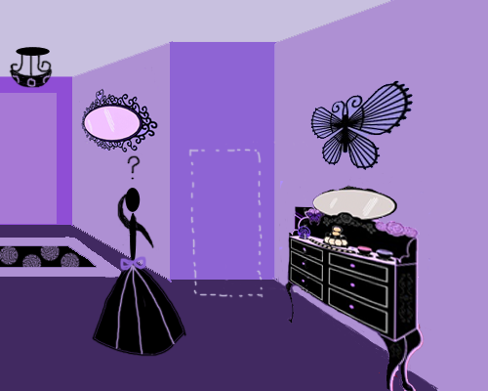

1. Perhaps you will suddenly find that something should be taken to fill your empty corner. Flowers? Or pictures?



2. Anyway, you might confuse with how to choose the right. Besides that, some difficulties still make you upset, such as absence of the slightest thought about design, inconvenience of going downtown and unsoundness due to shopping online by just looking at pictures. When you find nobody to consult with and fall into extremely helplessness indeed, IIROOM will help you settle all your problems.

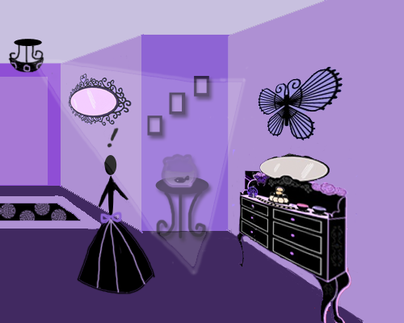

3. By using the IIROOM, take photos of your furniture now, or …huh, you like purple and your home furnished with antiques? Tell IIROOM！And he will help you! The DNA core will give you useful information by analyzing your preference and show the goods anywhere, and you prefer with our amazing holographic projector. Even more, you can go shopping in the simulated store created by holographic projection, and, of course, this depends on the size of your room. Wanna something cooler? It is real a fantastic shopping style to talk with the shop assistants face to face. Isn’t it? In addition, we also provide both gesture and human languages instructions to make IIROOM adapt your own habits.

**Second: Help you attend a meeting in a distance**

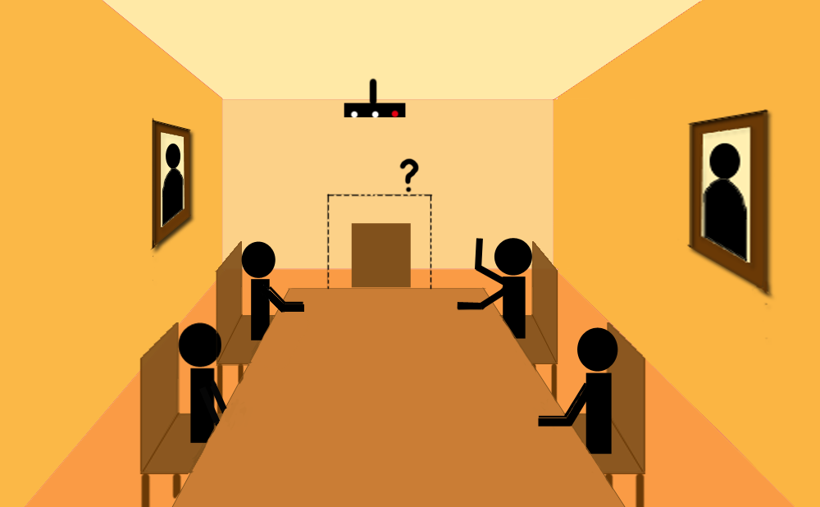

1. You never late colleague is not on his site now, why?



2. There is discussion on his probable absence, which refers to news that he is still abroad. So you blame his breach of duty in your heart? Actually, IIROOM accomplish an arduous task that never be completed before.

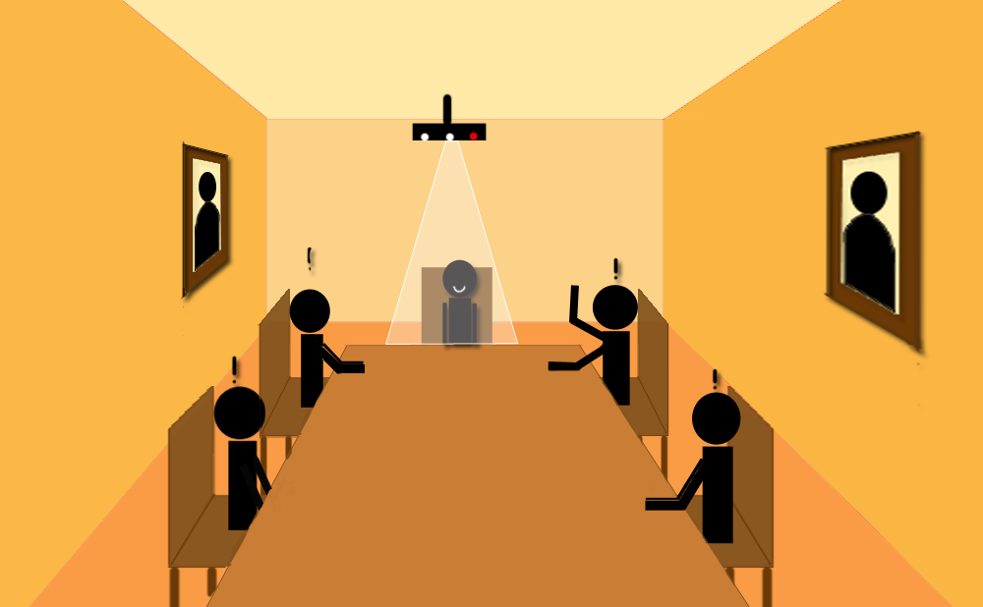

3. What happens? He transfers his image to your conference by IIROOM and incepts the image of yours and surrounding at the same time. There is no an inauthentic phone or a disobliging email. Instead of that, IIROOM show you almost real scene and based on strong communication core, ensure the synchronization of sounds and images, which does benefit to keep smooth progress of conference. Moreover, aim at guarantee information security, IIROOM use religious user register and log in. According to the demand of users, IIROOM also can encrypt and decipher brain-wave. Before formal use, users must save their individual information needed by passport authentication. (These are top secrets except they used by government security bureau and yourself.) Expressly, for some software needing high-level security, IIROOM arranges few times of passport authentication. You just enjoy your work and life, that’s all.

**Third: To help you draft by using 3D**



1. As an engineer, inspiration suddenly crosses into your mind one night., such as a splendid architectural structure.



2. How to describe it within the shortest time? Using a pencil to draw it down or designing it with your computer? No, no, no, it’s too late. After all, inspiration fleets in a flash. Don’t lose your inspiration, will you? IIROOM definitely can give you a hand.

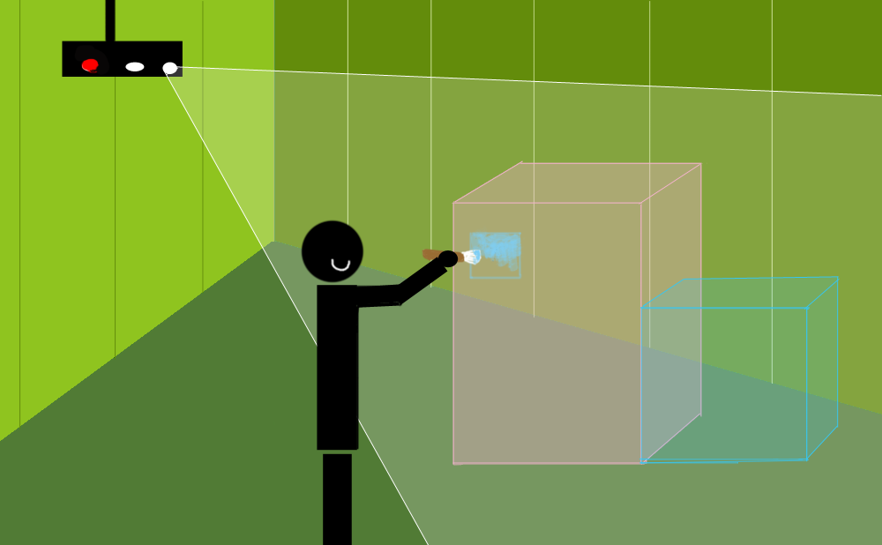

3. Using course is simple. Just call out the design suite in your favorite way. Other than before, IIROOM provide completely new 3D design software to sustain your original creation. You can draw in your own space built by holographic projection. Through shaking your hands to spin your building, the times that we can never see the back of a picture have gone forever. After painting completed, your work can be stored on storage core and prepared for use any time. Furthermore, for some software officially released, DNA core can organize several of them to meet your demand. For example, you both like function A in software ‘a’ and function B in software ‘b’, IIROOM can mix them into a new software to offer better service for you.

We stress both somatosensory interaction and grow by DNA of system in our design.

Hence, IIROOM is not only a new system, but also an assistant helping you to solve problems, which plays an essential role in our life. He stands for a new era with his “particular form of life”.

Besides the progress of core, IIROOM will grow up promoted by ridiculous amounts of third-party software. Even without professional knowledge, you can invent your software and serve others and yourself. So far as to that, you may earn considerable profits.

Finally, we conclude our brief introduction with few words: IIROOM can do almost everything for you!